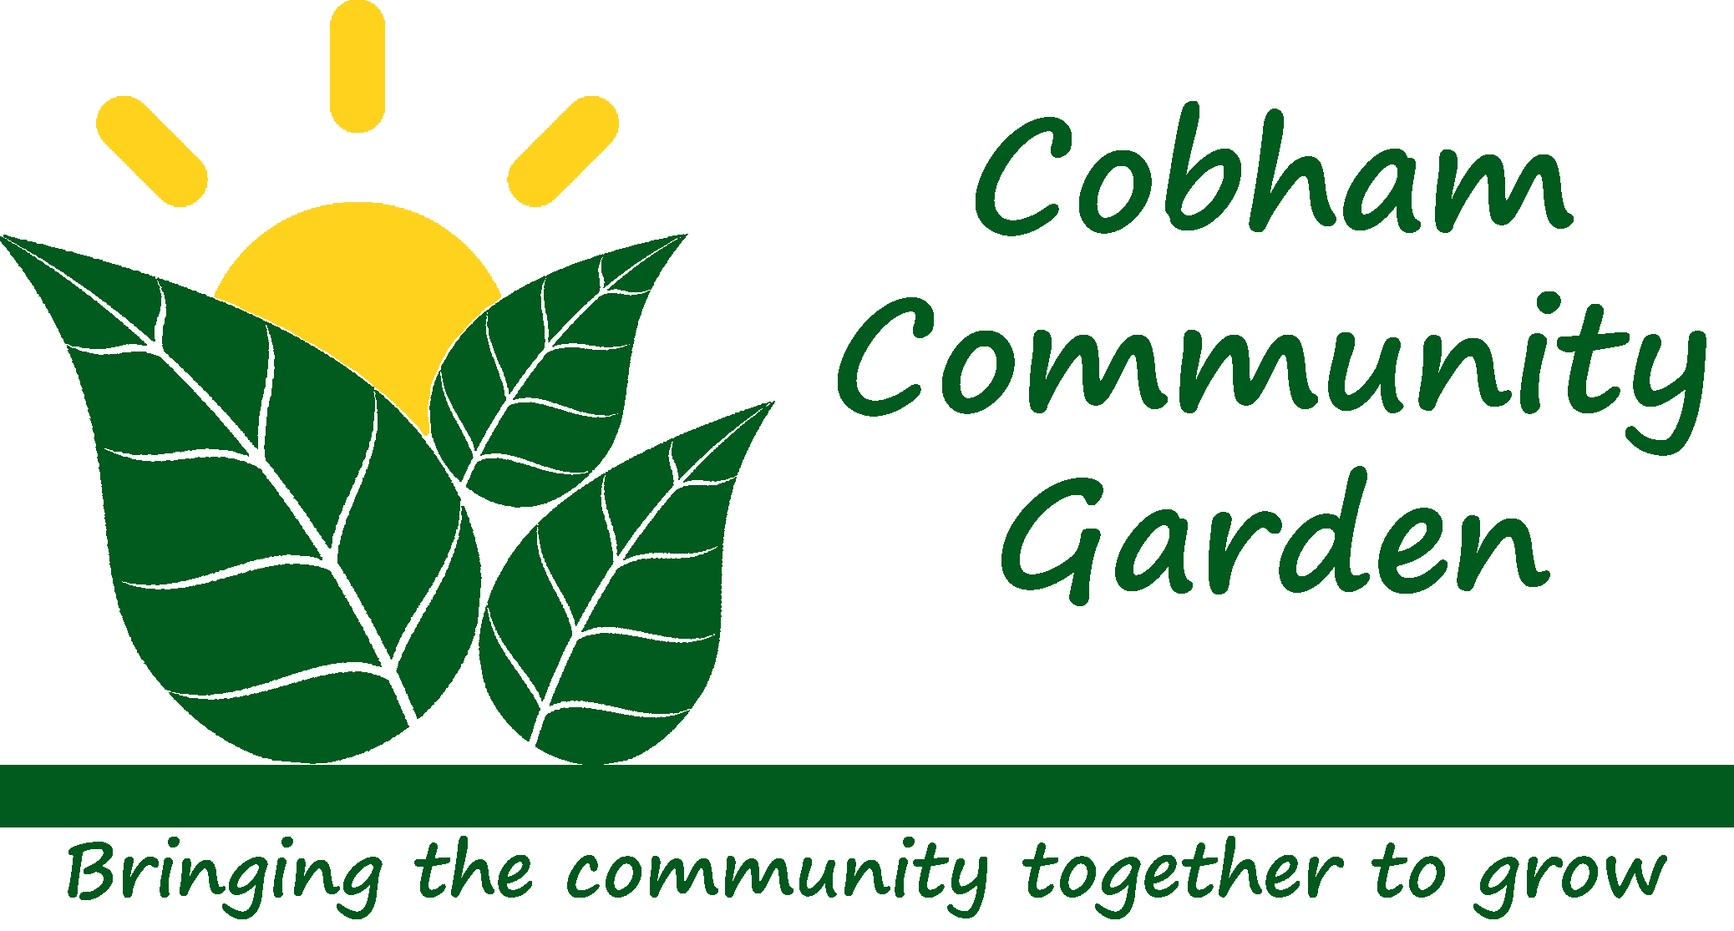
Come and join us!
in the garden

Starts March 7th 2020
Leg O’Mutton Field, Cobham
Saturdays 10-12 noon

- Come for good company, gardening skills, fresh air, or just a bit of exercise

Saturdays 10–12noon
- No need to bring any equipment
- Choose what type of gardening you want
to/can do
- and take some produce home!

www.CobhamCommunityGarden.org.uk
email: Hello@CobhamCommunityGarden.org.uk

